Semester Two Examination, 2021

Question/Answer booklet

SPECIALIST MATHEMATICS
UNITs 3&4

Section Two:

Calculator-assumed

Your Name

Your Teacher’s Name

Time allowed for this section
Reading time before commencing work: ten minutes
Working time: one hundred minutes

Materials required/recommended for this section
To be provided by the supervisor
This Question/Answer booklet
Formula sheet (retained from Section One)

To be provided by the candidate
Standard items: pens (blue/black preferred), pencils (including coloured), sharpener, correction fluid/tape, eraser, ruler, highlighters

Special items: drawing instruments, templates, notes on two unfolded sheets of A4 paper, and up to three calculators approved for use in this examination

Important note to candidates
No other items may be taken into the examination room. It is your responsibility to ensure that you do not have any unauthorised material. If you have any unauthorised material with you, hand it to the supervisor before reading any further.
Question | Marks | Max | Question | Marks | Max
9 |  |  | 16
10 |  |  | 17
11 |  |  | 18
12 |  |  | 19
13 |  |  | 20
14 |  |  | 21
15

Structure of this paper

Section | Number of questions available | Number of questions to be answered | Working time (minutes) | Marks available | Percentage of examination
Section One:  Calculator-free | 8 | 8 | 50 | 51 | 35
Section Two:  Calculator-assumed | 13 | 13 | 100 | 101 | 65
 |  |  |  | Total | 100

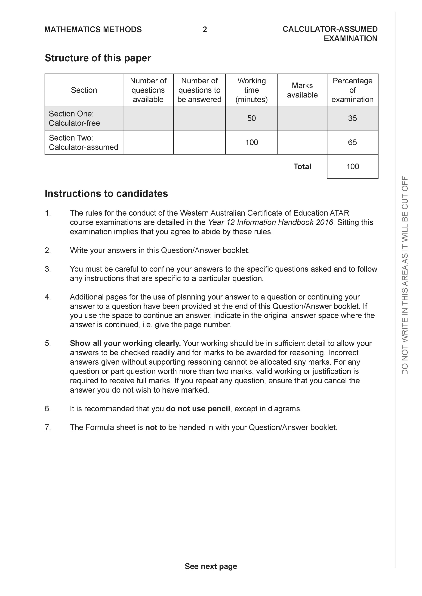

Section Two: Calculator-assumed (101 Marks)

This section has 13 questions. Answer all questions. Write your answers in the spaces provided.

Spare pages are included at the end of this booklet. They can be used for planning your responses and/or as additional space if required to continue an answer.
● Planning: If you use the spare pages for planning, indicate this clearly at the top of the page.
● Continuing an answer: If you need to use the space to continue an answer, indicate in the original answer space where the answer is continued, i.e. give the page number. Fill in the number of the question that you are continuing to answer at the top of the page.

Working time: 100 minutes.

Question 9 (4 marks)

A glass bowl is formed by rotating the curve cm from cm about the y axis as seen below. Determine the maximum capacity in litres given that .
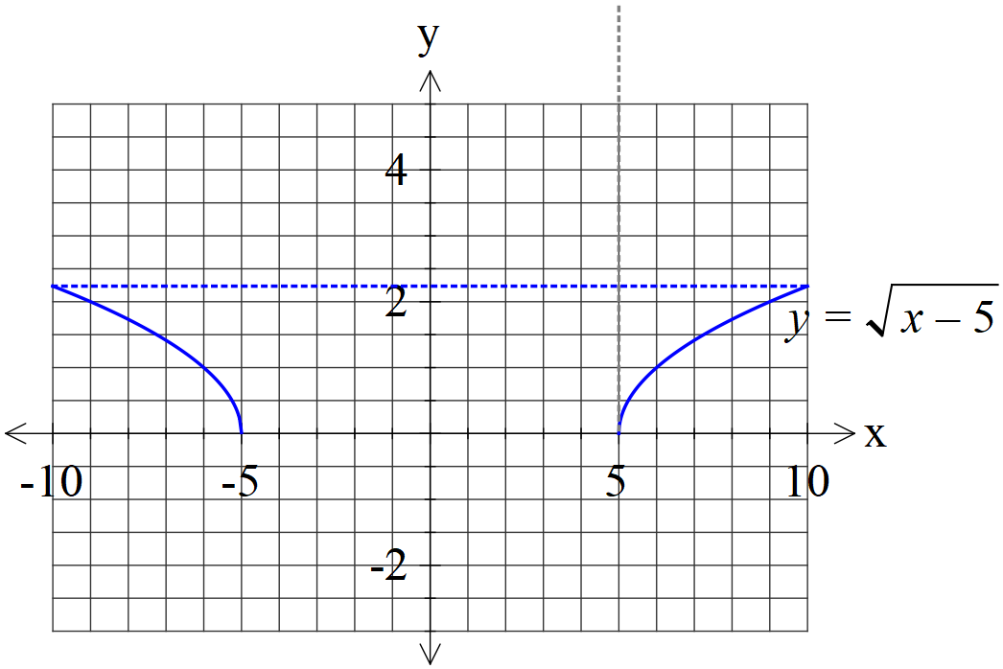

Question 10 (7 marks)

- Consider the locus where are real constants. See diagram below. Given that this locus is also given by , determine the exact values of and plot this point on the axes below. (4 marks)

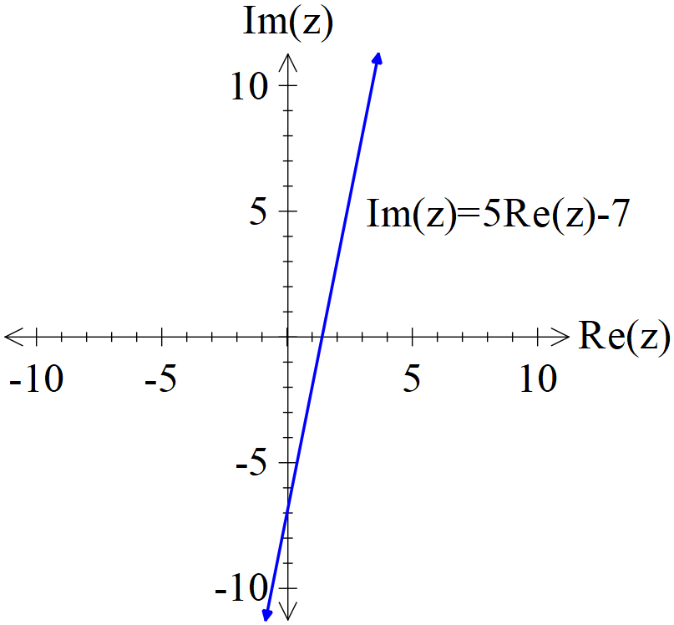

- Sketch the locus on the axes below. (3 marks)

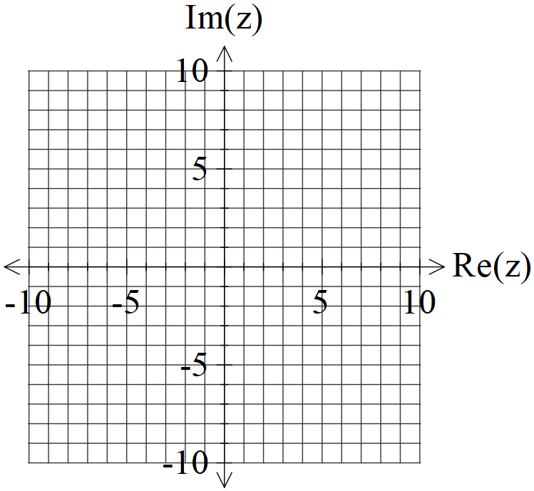

Question 11 (4 marks)

Consider the following complex numbers.

Determine in cartesian form.

Question 12 (11 marks)

Consider a racing car that follows the following path on a surface.
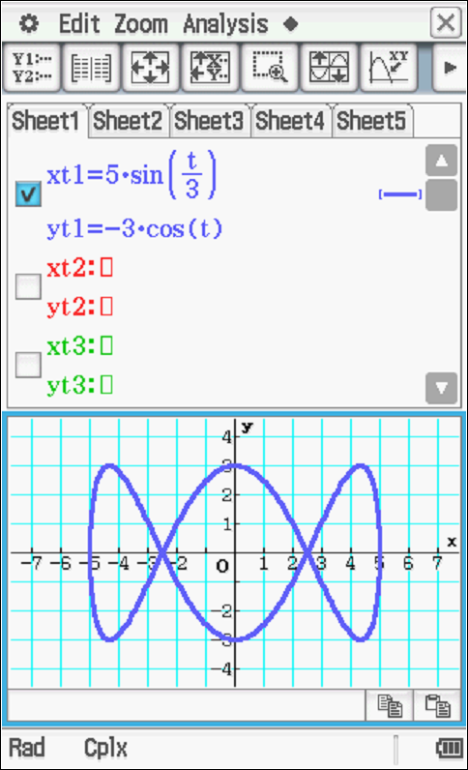

The car’s position vector is given by at time hours.
- Determine the initial velocity and position and mark the direction on the diagram above.
(4 marks)

- Determine the time taken to complete one circuit. (hours) (2 marks)

- Determine the initial acceleration. (2 marks)

- Determine to the nearest metre the distance travelled in one circuit. (3 marks)

Question 13 (7 marks)

- Determine the solutions to in the form with .
(4 marks)

- Plot these solutions on the axes below. (3 marks)

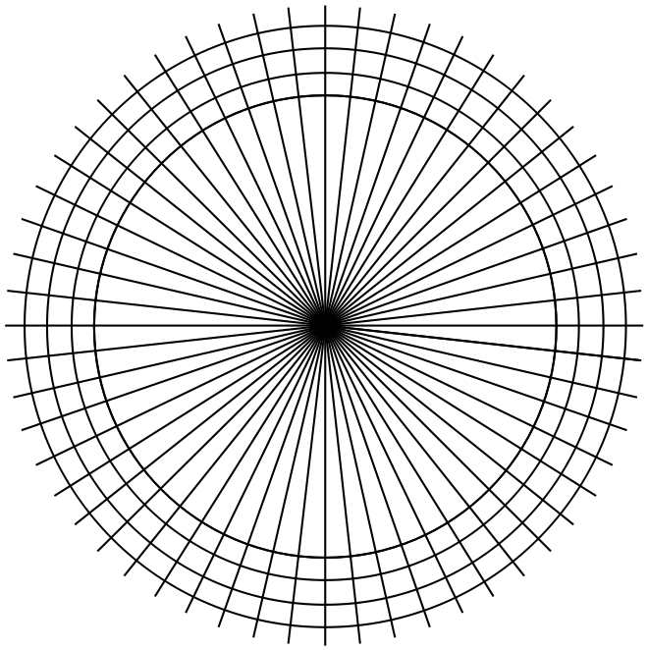

Question 14 (7 marks)

A particle moves in a straight line with the displacement from the origin, metres satisfies the
following differential equation at time seconds.
The particle is a rest at metres.

- Determine the speed when metres. (3 marks)

- Determine the percentage of the time that the object is less than 4 metres from the origin. (4 marks)

Question 15 (4 marks)

Consider the cross section of a football is given by . See diagram below.
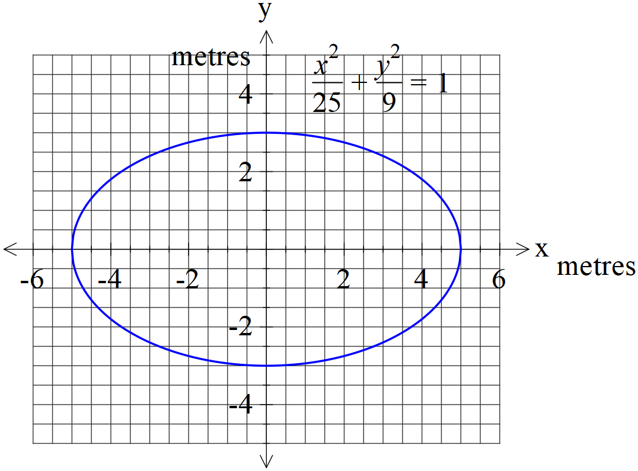
If the curve above is revolved around the x axis forming a 3-D football, determine the
exact volume in cubic metres.

Question 16 (7 marks)

Car manufacturer Subaru makes engines for their BRZ sports car with equaling the population mean engine power in kilowatts for the engine and being the population standard deviation.
A sample of engines was examined and a 90% confidence interval for was given as kilowatts.

- Determine the sample mean for this confidence interval. (1 mark)

- Determine the sample mean standard deviation for this confidence interval. (2 marks)

Another sample of engines was taken but this time the sample size is tripled.

- Determine the probability that the sample mean of this larger sample will differ from by more than 12 kilowatts. (4 marks)

Question 17 (11 marks)

A new species of tomato Type X has a weight that is normally distributed with mean = 37.2 grams and standard deviation =11.9 grams.

- Determine the probability that a bunch of 80 Type X tomatoes will weigh between 3.1 kg and 4.2 kg. (4 marks)

- If the probability that a new sample of Type X tomatoes has a mean weight that differs from by more than 0.5 grams is 4.2%, determine the sample size . (3 marks)

A rival species of tomato Type Y has a standard deviation of 7.8 grams (one tomato).
A bunch of 150 Type Y tomatoes has a weight of 6.02 Kg. The people who produce Type Y tomatoes claim that their tomatoes are heavier than Type X tomatoes.

- Show calculations that would allow better comment on which tomato is heavier.
(4 marks)

Question 18 (14 marks)
The number of algae, N thousands, in a habitat at time days is given by .

- Determine the initial number of algae. (2 marks)

- Determine the limiting number of algae after many decades. (2 marks)

- Express the rate of growth in the form stating the values of the constants . (2 marks)

- Sketch the graph of on the axes below and explain what is happening. (4 marks)

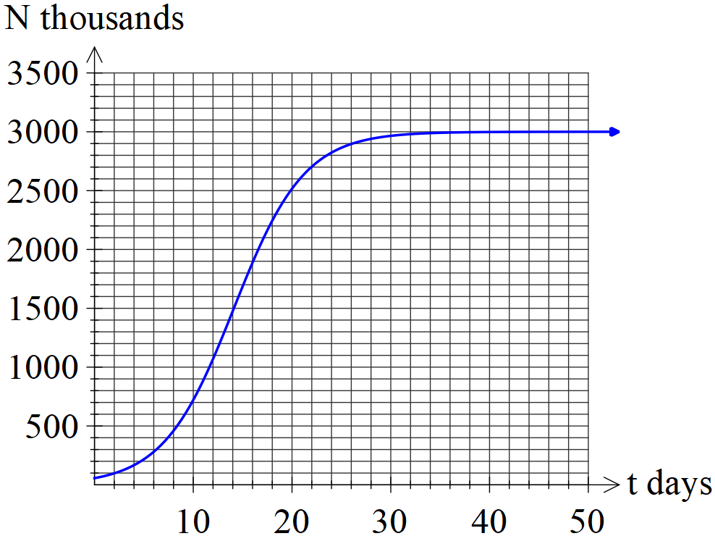

Q18 cont

- If the rate of growth was given by where are positive constants, show using integration and partial fractions how to derive with constant . (4 marks)

Question 19 (8 marks)

Consider a parent riding on a Ferris wheel looking down at her child who is left at the entrance to the Ferris wheel. Assume that the Ferris wheel moves with constant angular speed,
rads/sec, and a radius of 50 metres. Let the distance of direct eye contact from parent to child be represented as L metres.

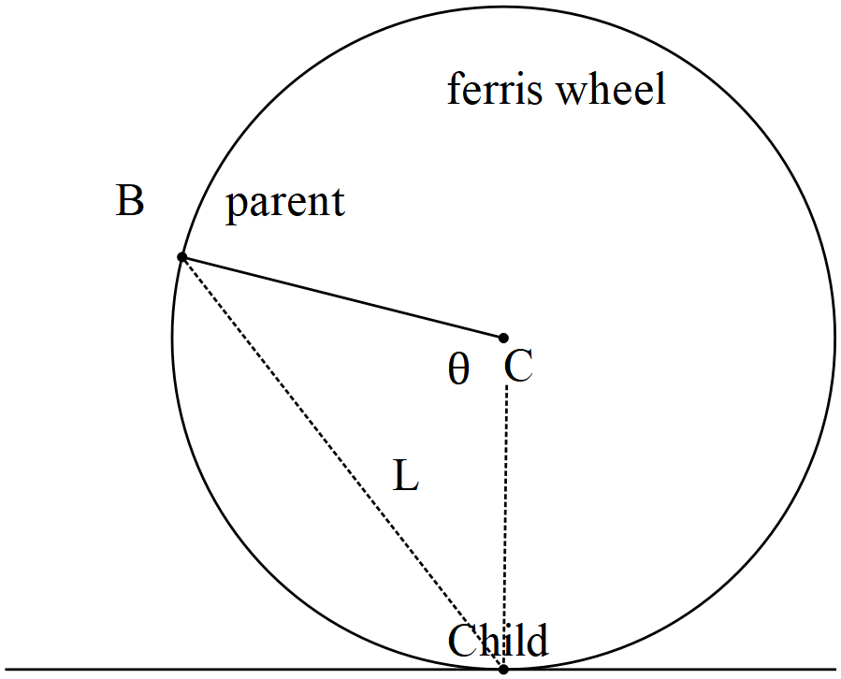

- Determine when . (4 marks)

- Determine the when . (4 marks)

Question 20 (8 marks)

- Determine the distance of Point A(2, -7, 11) to the plane showing full reasoning and working. (4 marks)

- Consider the lines below and determine minimal distance between them.
Show full reasoning and working (4 marks)
Question 21 (9 marks)
Consider the locus defined by which contains point A(5,2). See diagram below.
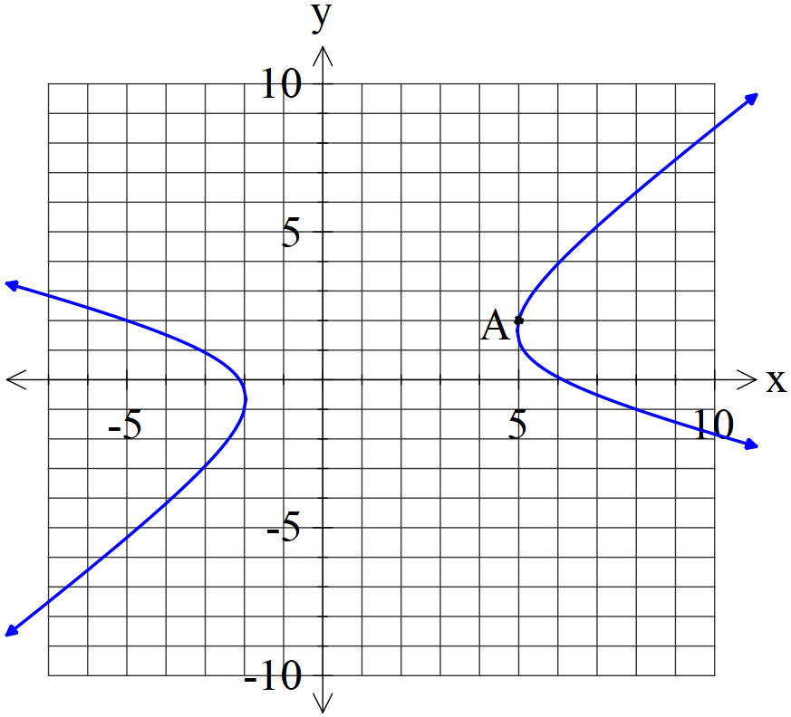

- Determine the equation of the tangent at point A. Show full reasoning and working without the use of a classpad. (4 marks)

- Determine at point A. Show full reasoning and working. (3 marks)

- Determine the relationship between at the points where the tangent is vertical.
(2 marks).

Additional working space
Question number:

Additional working space
Question number:

Additional working space
Question number:

Acknowledgements

